Teachers Report
10Y2 - 2012/2013
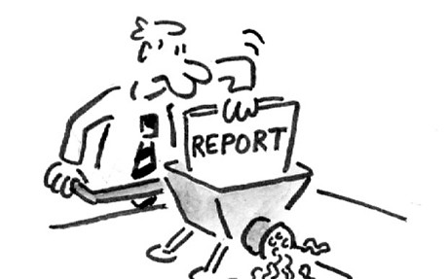
Enjoyment
- Do you enjoy maths? Why/ Why not?

- What could Mr Robinson do to make his lessons more enjoyable?

Progress
- Do you feel your lessons are well planned and allow you to make progress? Why/ Why not?

- When do you make the most progress?

- What could Mr Robinson do next year to ensure you make better progress?

Seating
- What impact has the seating plan had on your progress this year?

General
- Are there any aspects of your class that prevent you from making progress?

- What does Mr Robinson do that really works for you?

- Are there any things that other teachers do that Mr Robinson should incorporate into his teaching?

Overview
Can you please write an overview of this year with 2 W.W.W’s and an E.B.I
W.W.W

W.W.W

E.B.I

