Objective: calculating a missing length on a right-angled triangle: Pythagoras’ Theorem

STANDARD QUESTION 1: For each of these triangles, work out the length of the hypotenuse
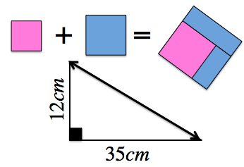 | 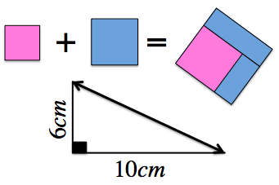 | 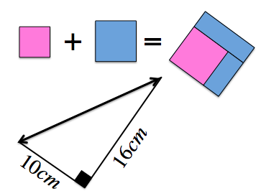
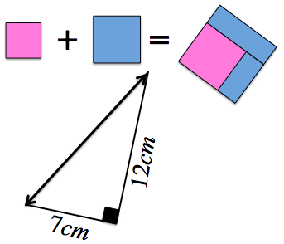 | 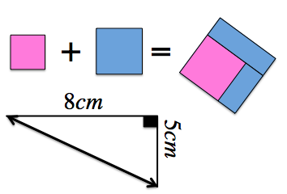 | 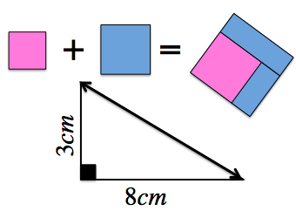
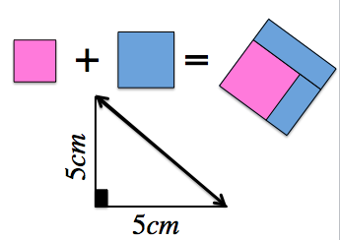 | 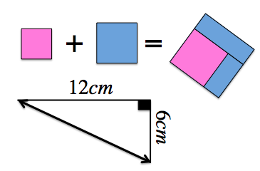 | 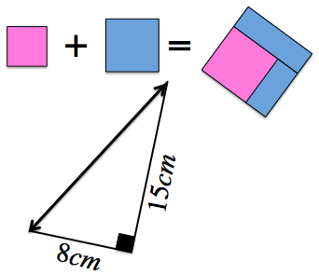

STANDARD QUESTION 2: Use what you have learnt to work out the length of one of the shorter sides
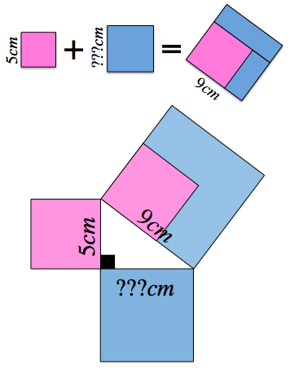 | 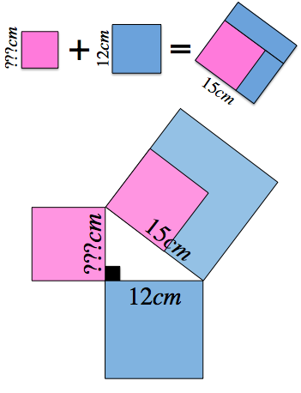
ACCELERATING QUESTION 3: For each of the following triangles, calculate the length of the missing side, giving your answers to one decimal place when needed.
3cm  6cm | 9cm  4cm | 5cm  10cm
7cm  8cm | 8cm  13cm | 4cm  4cm
10cm  10cm | 8cm  12cm | 10cm  x cm  x cm

ACCELERATED QUESTION 4: How long is the diagonal of a square with a side of 6 metres?

ACCELERATED QUESTION 5: A ship going from a port to a lighthouse steams 20 km east and 15 km north. How far is the lighthouse from the port?

ACCELERATED QUESTION 6: Calculate the area of these isosceles triangles
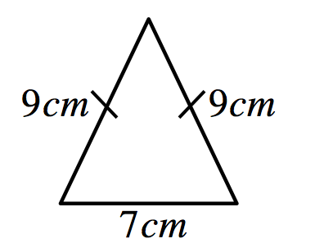 | 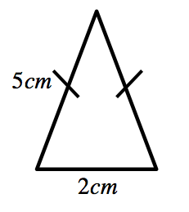 | 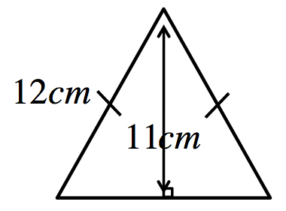

ACCELERATED QUESTION 7: Calculate the area of an equilateral triangle of side 7cm.

ANSWERS (Left to Right):
Question 1: 37, 11.7, 18.9, 13.9, 9.4, 8.5, 7.1, 13.4, 17
Question 2: 7.5, 9
Question 3: 6.7, 9.8, 11.2, 10.6, 15.3, 5.7, 14.1, 14.4, 7.1
Question 4: 8.5
Question 5: 25
Question 6: 58, 9.8, 105.5
Question 7: 42.4

ACCELERATING QUESTION 3: For each of the following triangles, calculate the length of the missing side, giving your answers to one decimal place when needed.
3cm  6cm | 9cm  4cm | 5cm  10cm
7cm  8cm | 8cm  13cm | 4cm  4cm
10cm  10cm | 8cm  12cm | 10cm  x cm  x cm

ACCELERATED QUESTION 4: How long is the diagonal of a square with a side of 6 metres?

ACCELERATED QUESTION 5: A ship going from a port to a lighthouse steams 20 km east and 15 km north. How far is the lighthouse from the port?

ACCELERATED QUESTION 6: Calculate the area of these isosceles triangles

ACCELERATED QUESTION 7: Calculate the area of an equilateral triangle of side 7cm.

ANSWERS (Left to Right):
Question 1: 37, 11.7, 18.9, 13.9, 9.4, 8.5, 7.1, 13.4, 17
Question 2: 7.5, 9
Question 3: 6.7, 9.8, 11.2, 10.6, 15.3, 5.7, 14.1, 14.4, 7.1
Question 4: 8.5
Question 5: 25
Question 6: 58, 9.8, 105.5
Question 7: 42.4

