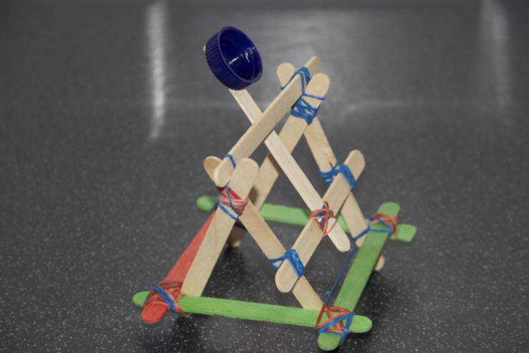[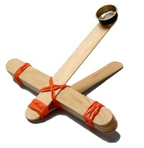](http://www.google.co.uk/url?sa=i&rct=j&q=lollipop%2Bcatapult&source=images&cd=&cad=rja&docid=hfQcA6_9YeVW7M&tbnid=qzQknJWbOsEh8M:&ved=0CAUQjRw&url=http%3A%2F%2Fpinterest.com%2Fnplibrary%2Fcrafty%2F&ei=pd3BUdO6Jsu10QWZ54DICw&bvm=bv.47883778,d.ZG4&psig=AFQjCNHIYXzDvBeUjHHZYaSuaGtu1IX1Ig&ust=1371746079436546)

[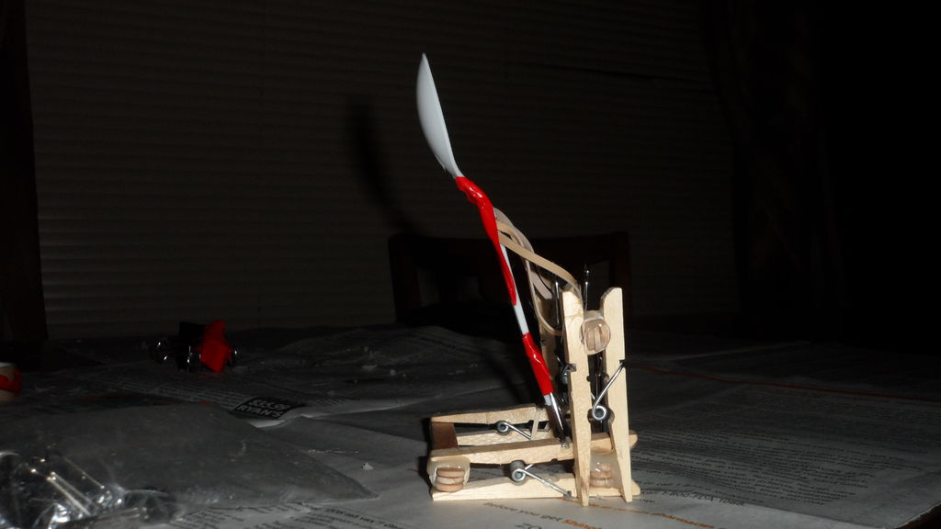](http://www.google.co.uk/url?sa=i&rct=j&q=lollipop%2Bcatapult&source=images&cd=&cad=rja&docid=lHA_MP6PJE1wgM&tbnid=lFdI7xOdQjeMEM:&ved=0CAUQjRw&url=http%3A%2F%2Fwww.instructables.com%2Fid%2FHow-to-make-a-spoon-catapult%2F&ei=uN3BUeqJBKyU0QWO6oHICw&bvm=bv.47883778,d.ZG4&psig=AFQjCNHIYXzDvBeUjHHZYaSuaGtu1IX1Ig&ust=1371746079436546)

[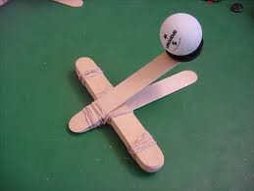](http://www.google.co.uk/imgres?q=lollipop+catapult&um=1&safe=active&hl=en&biw=1280&bih=929&tbm=isch&tbnid=prEiZmCCm25-OM:&imgrefurl=http://www.superchargedscience.com/ar/catapults-042.htm&docid=KjFgwSAeMvpZFM&imgurl=http://www.superchargedscience.com/images/catapult.jpg&w=400&h=301&ei=nt3BUbemOY6zhAfS9YDIBw&zoom=1&ved=1t:3588,r:74,s:0,i:310&iact=rc&page=3&tbnh=195&tbnw=258&start=52&ndsp=28&tx=122&ty=119)[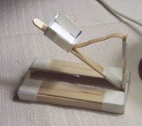](http://www.google.co.uk/url?sa=i&rct=j&q=lollipop%2Bcatapult&source=images&cd=&cad=rja&docid=dBHC3aOg6LH83M&tbnid=6HESP0uOI5WTVM:&ved=0CAUQjRw&url=http%3A%2F%2Fwww.stormthecastle.com%2Fcatapult%2Ffree-catapult-plan.htm&ei=Wt7BUctyiNjRBfTQgMAL&bvm=bv.47883778,d.ZG4&psig=AFQjCNHIYXzDvBeUjHHZYaSuaGtu1IX1Ig&ust=1371746079436546)

[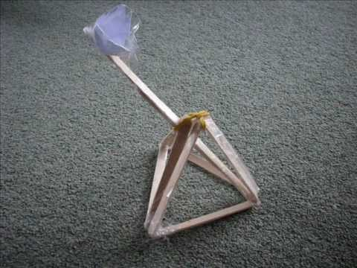](http://www.google.co.uk/url?sa=i&rct=j&q=lollipop%2Bcatapult&source=images&cd=&cad=rja&docid=p3JACFFxgLw3tM&tbnid=WeP0Wc0UoHvB1M:&ved=0CAUQjRw&url=http%3A%2F%2Fwww.youtube.com%2Fwatch%3Fv%3DSvJeWhAwrO8&ei=dt7BUZX4La2g0wXUiYCwCw&bvm=bv.47883778,d.ZG4&psig=AFQjCNHIYXzDvBeUjHHZYaSuaGtu1IX1Ig&ust=1371746079436546)[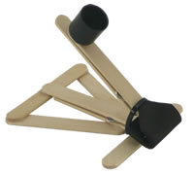](http://www.google.co.uk/url?sa=i&rct=j&q=lollipop%2Bcatapult&source=images&cd=&cad=rja&docid=FS1oqPAte8T3bM&tbnid=arPWmxYJvT8WHM:&ved=0CAUQjRw&url=http%3A%2F%2Fwww.sonicdad.com%2Fprojects&ei=jN7BUfL4FpC20QXgp4CoCg&bvm=bv.47883778,d.ZG4&psig=AFQjCNHIYXzDvBeUjHHZYaSuaGtu1IX1Ig&ust=1371746079436546)