Plotting Straight Line Graphs (Grade D) – Answers
Use the following tables and graphs to mark your own work
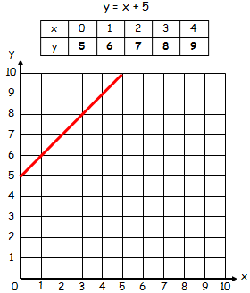
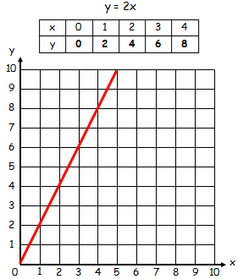
- 2)

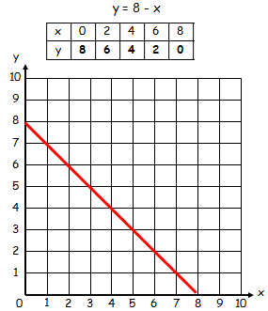
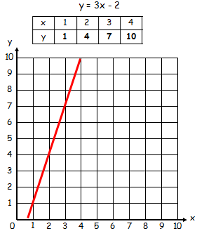
- 4)

Plotting Straight Line Graphs in Four Quadrants (Grade D) - Answers
Use the following tables and graphs to mark your own work

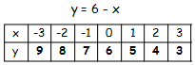
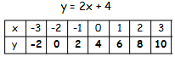
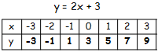
- 2) 3)
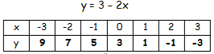
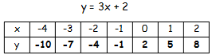
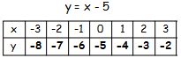
- 5) 6)

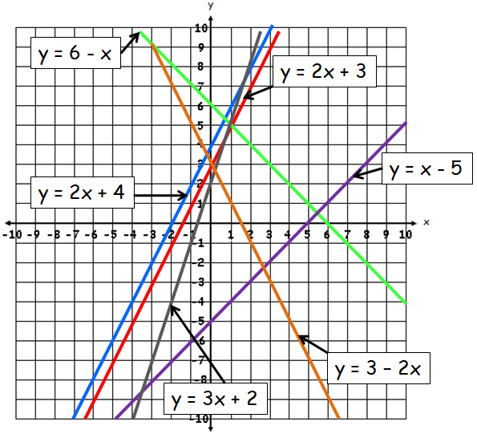

7) What do you notice about all of the lines that have a (- x) term in them? (e.g. 6 – x)
They are all sloping downwards (from top left to bottom right)
8) What do you notice about the two graphs y = 2x + 3 and y = 2x + 4?
They are parallel
9) Using your answer to question 8, give the equation of two lines that are parallel to y = 3x + 2
e.g. 3x + 1, 3x + 3, 3x + 4, 3x – 1. Any equation 3x + c is correct.

