Plotting Straight Line Graphs
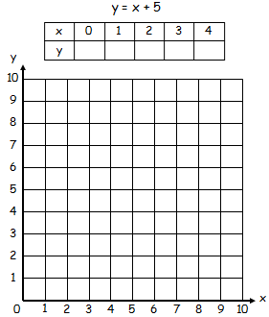
Complete the following tables and plot the graph on the corresponding axis
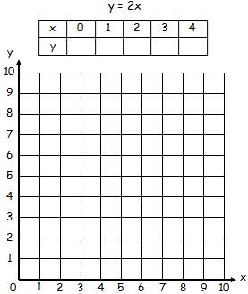
- 2)

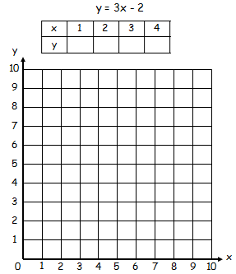
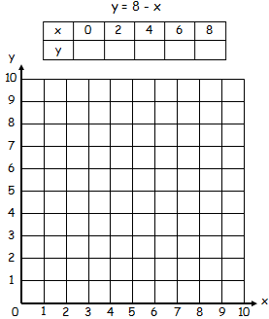
- 4)

Plotting Straight Line Graphs in Four Quadrants
Complete the following tables and then plot each graph on the SAME AXIS below. Make sure to label each graph with its equation (e.g. y = 2x + 3)
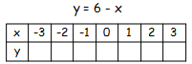
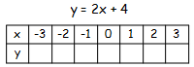
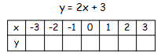
- 2) 3)

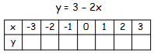
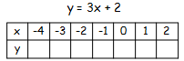
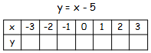
- 5) 6)
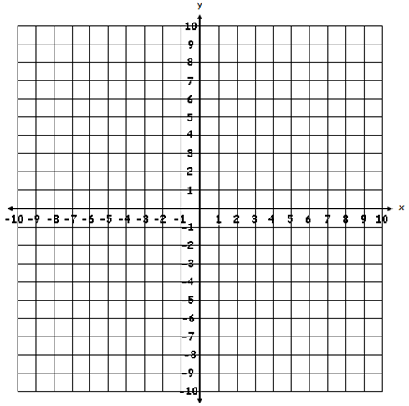

7) What do you notice about all of the lines that have a (- x) term in them? (e.g. 6 – x)
___________________________________________________________________________
8) What do you notice about the two graphs y = 2x + 3 and y = 2x + 4?
___________________________________________________________________________
9) Using your answer to question 8, give the equation of two lines that are parallel to y = 3x + 2
___________________________________________________________________________

