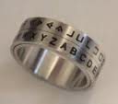 Pig Pen Cipher 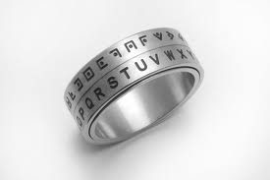

The Pig Pen Cipher is one of the oldest types of code. Each letter is swapped for a symbol depending on its place in the ‘Pen’

So A is written as
K is written as .

S is written as

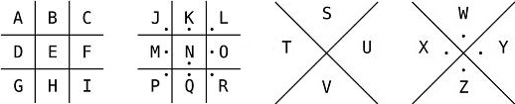

Look at how this message has been coded.
