Colomendy Pack

Name:-

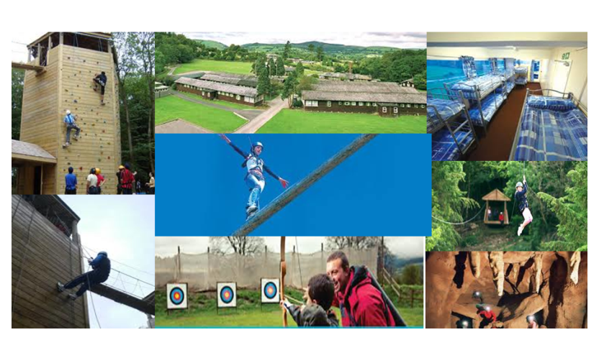

Colomendy Numeracy Pack



Pre visit:-

My mentor is ……………………………………………………………………

My key target to improve is …………………………………………

What I would like to get out of Colomendy

1)

2)

3)

Mazes

 

Learning outcomes

1. To be resilient, to not give up. (level 4 skill)
2. To develop a strategy to solve the maze

(level 4 – 5 skill)

1. To justify why there is only one solution

(level 5 – 6 skill)

1. To make my own maze (level 5) with a unique answer (level 6)

I learned :-

From now on I will :-

My Maze

|  |  |  |  |  |
| --- | --- | --- | --- | --- |
|  |  |  |  |  |
|  |  |  |  |  |
|  |  |  |  |  |
|  |  |  |  |  |
|  |  |  |  |  |

Times Table Hands

Making sums What is the sum?

|  |  |
| --- | --- |
| \\taw.org.uk\zone7\Homes\taw700staff\Darryn.robinson\Literacy and Numeracy\catch up premium\Activities\Student pack\photo 2.JPG |  |
| \\taw.org.uk\zone7\Homes\taw700staff\Darryn.robinson\Literacy and Numeracy\catch up premium\Activities\Student pack\photo 1.JPG |  |
| \\taw.org.uk\zone7\Homes\taw700staff\Darryn.robinson\Literacy and Numeracy\catch up premium\Activities\Student pack\photo 3.JPG |  |
| \\taw.org.uk\zone7\Homes\taw700staff\Darryn.robinson\Literacy and Numeracy\catch up premium\Activities\Student pack\photo 4.JPG |  |
| \\taw.org.uk\zone7\Homes\taw700staff\Darryn.robinson\Literacy and Numeracy\catch up premium\Activities\Student pack\photo 5.JPG |  |

Division

4 x 3 = so ….

8 x 5 = so …………

6 x 21 = so …………….

I can use multiplication to divide by …

Complete the following

42 ÷ 7 =

45 ÷ 9 =

21 ÷ 3 =

56 ÷ 8 =

Now challenge your mentor to four in a row

Balloon Tetrahedrons

Step 1 – Blow up one balloon leaving about 1 cm at the end

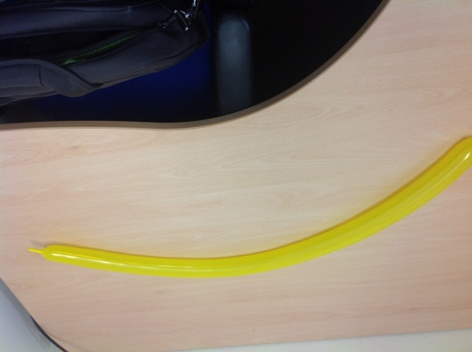

Step 2 – Blow up second balloon about half way.

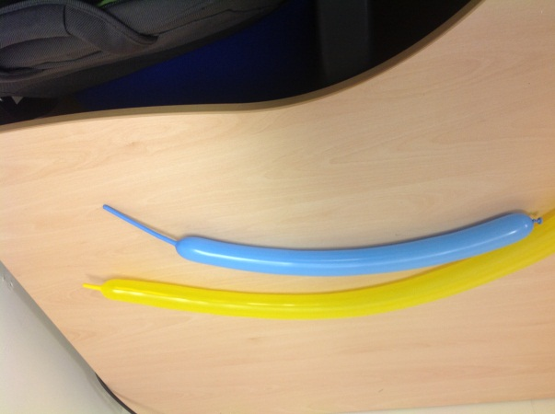

Step 3 – With big balloon – make a bubble, split into quarters – making a triangle with an extra ‘leg’

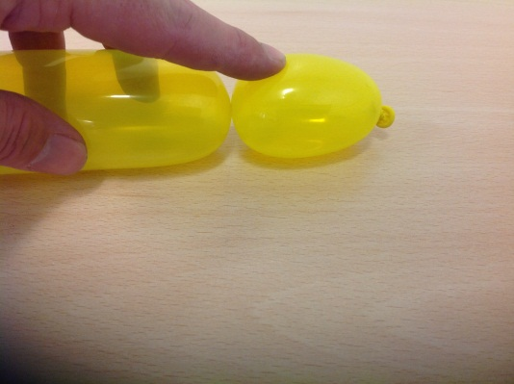

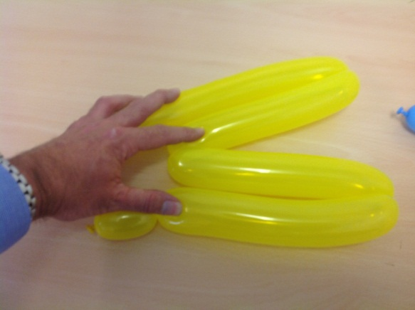 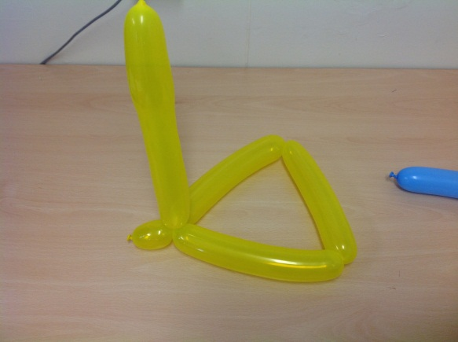

Step 4 – With the smaller balloon make a bubble, secure to one of the vertices, twist in half and make a bubble to secure to the other vertex.

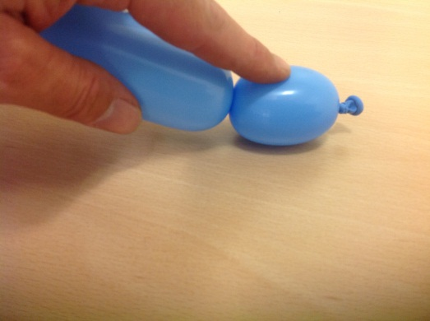 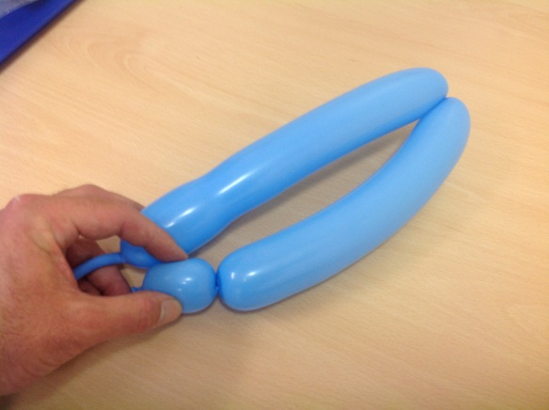

Step 5 – fix your extra ‘leg’

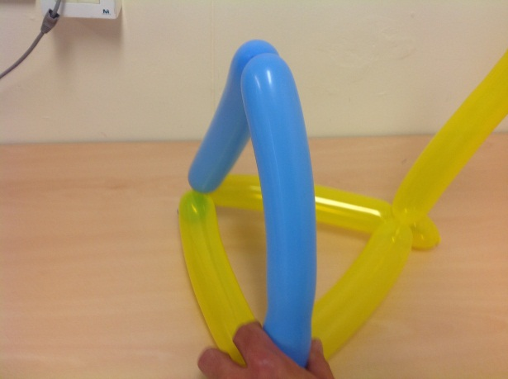 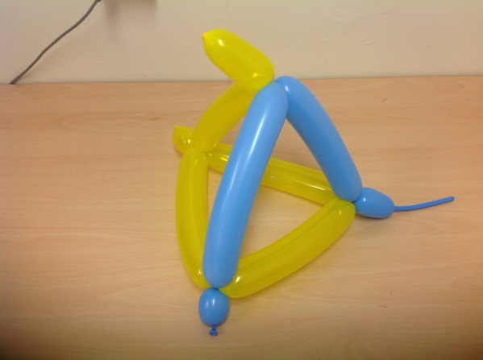

I learned :-

Extending the number square

**48**

**19**

**61**

**62**

**63**

**64**

**65**

**66**

**67**

**68**

**69**

**70**

**51**

**52**

**53**

**54**

**55**

**56**

**57**

**58**

**59**

**60**

**21**

**22**

**23**

**24**

**25**

**26**

**27**

**28**

**29**

**30**

**31**

**32**

**33**

**34**

**35**

**36**

**37**

**38**

**39**

**40**

**1**

**2**

**3**

**4**

**5**

**6**

**7**

**8**

**9**

**10**

**41**

**42**

**43**

**44**

**45**

**46**

**47**

**49**

**50**

**11**

**12**

**13**

**14**

**15**

**16**

**17**

**18**

**20**

**91**

**92**

**93**

**94**

**95**

**96**

**97**

**98**

**99**

**100**

**81**

**82**

**83**

**84**

**85**

**86**

**87**

**88**

**89**

**90**

**71**

**72**

**73**

**74**

**75**

**76**

**77**

**78**

**79**

**80**

**90**

**61**

**11**

Find 10 things to tell your mentor about the patterns in the numbers.

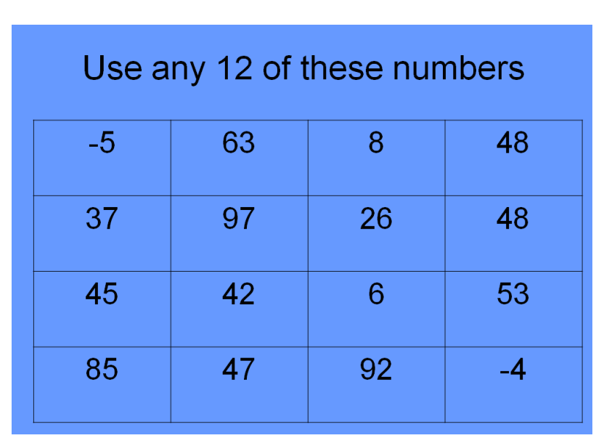

Write them in the grid below

|  |  |  |  |
| --- | --- | --- | --- |
|  |  |  |  |
|  |  |  |  |
|  |  |  |  |

Prize for first vertical line

Prize for first horizontal line

Prize for first full house

I learned :-

From now on I will :-

Times Table Hands

Making sums What are the units?

|  |  |
| --- | --- |
| \\taw.org.uk\zone7\Homes\taw700staff\Darryn.robinson\Literacy and Numeracy\catch up premium\Activities\Student pack\photo 2.JPG |  |
| \\taw.org.uk\zone7\Homes\taw700staff\Darryn.robinson\Literacy and Numeracy\catch up premium\Activities\Student pack\photo 1.JPG |  |
| \\taw.org.uk\zone7\Homes\taw700staff\Darryn.robinson\Literacy and Numeracy\catch up premium\Activities\Student pack\photo 3.JPG |  |
| \\taw.org.uk\zone7\Homes\taw700staff\Darryn.robinson\Literacy and Numeracy\catch up premium\Activities\Student pack\photo 4.JPG |  |
| \\taw.org.uk\zone7\Homes\taw700staff\Darryn.robinson\Literacy and Numeracy\catch up premium\Activities\Student pack\photo 5.JPG |  |

Division

Your mentor will show you how to complete short division. Use it to find the joke.

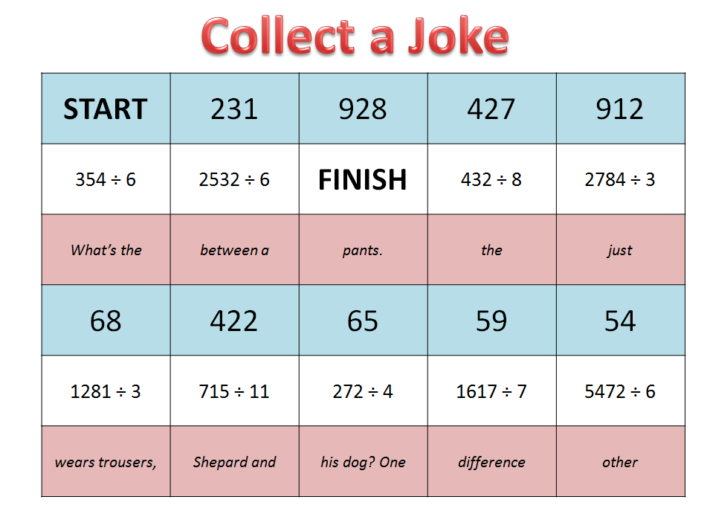

Catapult Averages

The Challenge –You have 35 minutes to build and test a catapult to fire a marshmallow the furthest distance possible.

You need to record the distance of 20 throws.

Prizes will be awarded for the highest mean, mode and median.

There will also be a prize for the shortest range (in the results – don’t confuse this with the range of your catapult)

Murder Mystery

Work with your mentor to solve the mystery. Prizes for the first to finish.

Times Table Hands

Making sums What are the tens?

Finish the sum.

|  |  |
| --- | --- |
| \\taw.org.uk\zone7\Homes\taw700staff\Darryn.robinson\Literacy and Numeracy\catch up premium\Activities\Student pack\photo 2.JPG |  |
| \\taw.org.uk\zone7\Homes\taw700staff\Darryn.robinson\Literacy and Numeracy\catch up premium\Activities\Student pack\photo 1.JPG |  |
| \\taw.org.uk\zone7\Homes\taw700staff\Darryn.robinson\Literacy and Numeracy\catch up premium\Activities\Student pack\photo 3.JPG |  |
| \\taw.org.uk\zone7\Homes\taw700staff\Darryn.robinson\Literacy and Numeracy\catch up premium\Activities\Student pack\photo 4.JPG |  |
| \\taw.org.uk\zone7\Homes\taw700staff\Darryn.robinson\Literacy and Numeracy\catch up premium\Activities\Student pack\photo 5.JPG |  |

Post visit:-

Read through the pre visit sheet you completed at the start

My key target to improve was …………………………………………

Did you achieve this? ………………………………….

The key things I learned at Colomendy

1)

2)

3)