Morse Code

In 1836, Samuel Morse demonstrated the ability of a telegraph system to transmit information over wires. The information was sent as a series of electrical signals. Short signals are referred to as dits (represented as dots). Long signals are referred to as dahs (represented as dashes). With the advent of radio communications, an international version of Morse code became widely used.

Morse code is not exactly as cipher as the message is not hidden, provided you have the coding for each letter the message can be easily decoded.

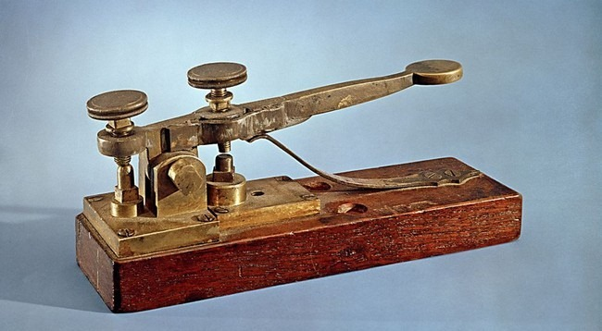

See additional sheet for translation

Extra note

- -..-- means comma

