Colomendy Pack

Name:-

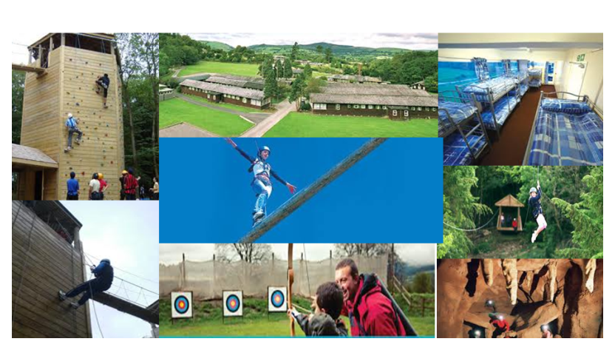

Mentor Pack



Pre visit:-

My pupil is ……………………………………………………………………

Their target to improve is …………………………………………

What I would like to get out of Colomendy

1)

2)

3)

Mazes 45 minutes

Shared outcomes

To be resilient in finding an answer (Level 4 skill)

To develop a strategy to solve the problem (Level 4 - 5 skill)

To decide if it is a unique answer and justify (Level 5 - 6 skill)

Pupils start with the number maze and counters – leave them to try and find the way to the centre.

When they start to give up guide a little and support, ask leading questions that encourage them to work backwards.

(How many squares actually lead to the goal? (there is only one)

How many squares will land on that? (there is only one)

If repeatedly lose their place encourage them to write on the sheet – if this makes it easier for them ask them why – relate to the importance of showing our working and writing down our thoughts.

Once completed ask pupils to reflect on what is it that made it difficult?

What made it approachable?

Did it ever get easy?

Was it achievable?

To share and discuss idea of being resilient and the satisfaction of getting it right afterwards.

 

Time Table Hands/ Divisions

Complete either depending on the specific target of your pupil.

For both activities when you play the grid game encourage as much as possible for them to find the answers independently. Don’t forget to praise!!!!

Point out when they get new things right.

Times Tables

For times table hands we are only at this time getting them to say the sums (eg that’s 4 x 6). They do not need to say how to get the answer from the hand positions, we will address this next lesson.

If they are confident saying the sums and you fell they could move on start to discuss with them first how the units work (then practise before introducing the tens)

Division

For Division – we are leading them to use times tables to find the answer to division sums. 4 x 3 = 12 so…. Ask them to write the two division sums that match this.

6 x 21 is deliberately more difficult – if they struggle ask them to write down 6 21’s (in column addition) and add them. Relate back to the mazes – it’s easier if we show our working out.

Balloon Tetrahedrons

Follow the instructions in the booklet. Discuss with the students the terms vertex, side and face. Can they explain to you what part of the shape demonstrates an area (this may take a little imagination), and which a volume (this will be a little easier)

Students may need support estimating ¼’s of the balloon (I did), it takes a few attempts to get it right.

Extending the Number Square

Discuss with the students the patterns on the number square (vertically up is +10, down is -10), ask what happens if we go up one and right one? up one and left one?

Can they think how this might help then when adding and subtracting numbers?

Can they close there eyes and visualise it.

Whole class activity

We will close packs and ask students to visualise the number square, to move about it and state the numbers they are ‘stood’ on. We are encouraging pupils to use movement around the number square to complete calculations efficiently (so if I add 19 I go up 2 and left 1)

Individual activity

Pupils to complete the number square, support with the negative numbers. Some will want to put -1 underneath 1. Ask them why, what is the pattern? Does -1 fit? If they are still unsure take them across to the 10’s column – what goes under 10? Then work left.

Bingo

Ensure pupils are calculating the correct answer, let them whisper it to you but not to shout it out. If they hear someone else’s answer ask them to explain why to you.

Let them use the 100 square if they need but bit by bit try and remove it so that they complete the sums independently.

Time Table Hands/ Divisions

Move your student onto their next step – stating the units or tens

If on division teach them bus stop division.

Catapult Averages

Build your own catapult, offer help where your pupil needs it. Ask your pupil to work out your results as well as there’s (for dividing by 20 can we divide by 2 then 10?)

Time Table Hands/ Divisions

All students should now be able to do all three sections of the times table hands.

Either complete the times table race/ find a joke

Pre visit:-

My pupil was ……………………………………………………………………

Their target to improve was …………………………………………

Did they achieve it?

Three things I will take away with me are:-

1)

2)

3)