Simpsons Answers
Sideshow Bob was the victim, the murderer was Mr Burns.

Bart  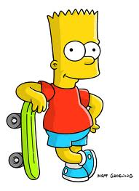  Bart paid $3.50 |  |  | Mr Burns  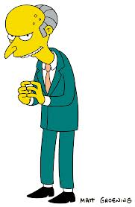  Mr Burns paid $3.62 |  |  |  | Mr Skinner paid $3.18
Ralph  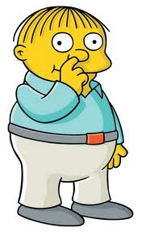  Ralph paid $3.02 |  |  | Sideshow Bob  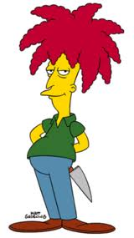  Sideshow Bob paid $2.06 |  |  |  | Millhouse  Millhouse paid £3.42
When
The murder took place on Tuesday 15th March
On the ___ day of the ______month
Where
Solve the following, find the difference between x and y (x-y) then match the answer to the place where the murder was committed.
5x + 2y = 16
20x + 3y= 49
-1 …………In the graveyard  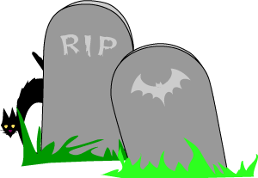 |  | 3 ……….In a haunted house |  |  | 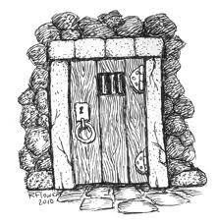  -4 ……… In a spooky dungeon |  |  | 2………… In a tall rickety tower
Why
Solve the following then use your answers to decode the murders message.
2T + 3E= 20 4I + 3R= 23 3A + M = 15 5H + U = 53
T + E= 7 2I + 5R = 29 A + 2M = 10 7H + 2U = 79

20S + 3F= 170
4S + 5F = 78
2 | 1 |  |  | 4 |  | 1 |  |  | 6
9 | 2 |  |  | 7 |  | 10 |  |  | 6
3 | 8 |  |  | 5
Final Accusation
_______________murdered __________________. In (where) _________on (when)______ because (why)_______________________

Answers
Who  - X = 3 y=4 vampire  - X= 2 y=5 ghost  - X= 5 y=3 witch  - X=6 y=8 zombie  Therefore the skeleton is murderer and the werewolf is victim | When  D = 5 f = 2  M = 11 n = 4  5th November
Where  X = 2 Y=3  Therefore x – y = -1 so it was in the graveyard | Why  It ate his femur

