Simpsons Mini Murder Mystery
Who
These are the 6 suspects in a murder.
Solve the division sums. The victim got the best deal, the murderer got the worst.
Bart  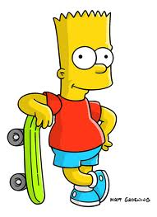  Bart bought 15 squishies for $52.50 | Mr Burns  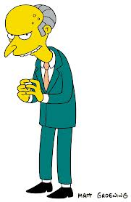  Mr Burns bought 14 Squishies for $50.68 | Mr Skinner bought 24 Squishies for $76.32
Ralph  Ralph bought 8 squishies for $24.16 | Sideshow Bob  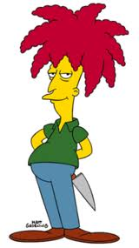  Sideshow Bob bought 9 Squishies for $18.54 | Millhouse  Millhouse paid $44.46 for 13 Squishies.
When
The Number in the Hundreds Column of the answer will tell you the day (Monday = 1 etc)
The Numbers in the tens and units columns will tell you the date ( 01 = 1st etc)
The Number in the tenths and hundredths columns will tell you the month (January = 1 etc)

Clue – Divide 1290.18 by 6

On ________________the ___ day of the ______month

