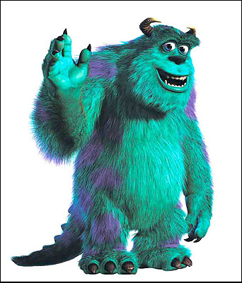 | 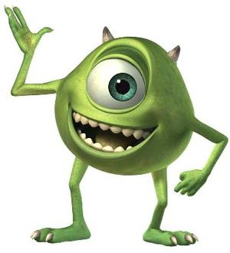 | 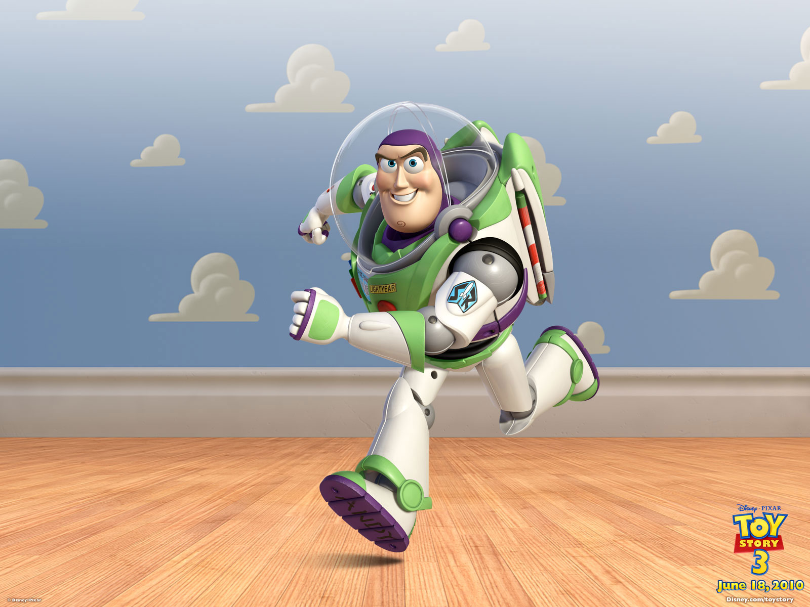
Special Skills:  Gadgets:  Comedy: | Special Skills:  Gadgets:  Comedy: | Special Skills:  Gadgets:  Comedy:
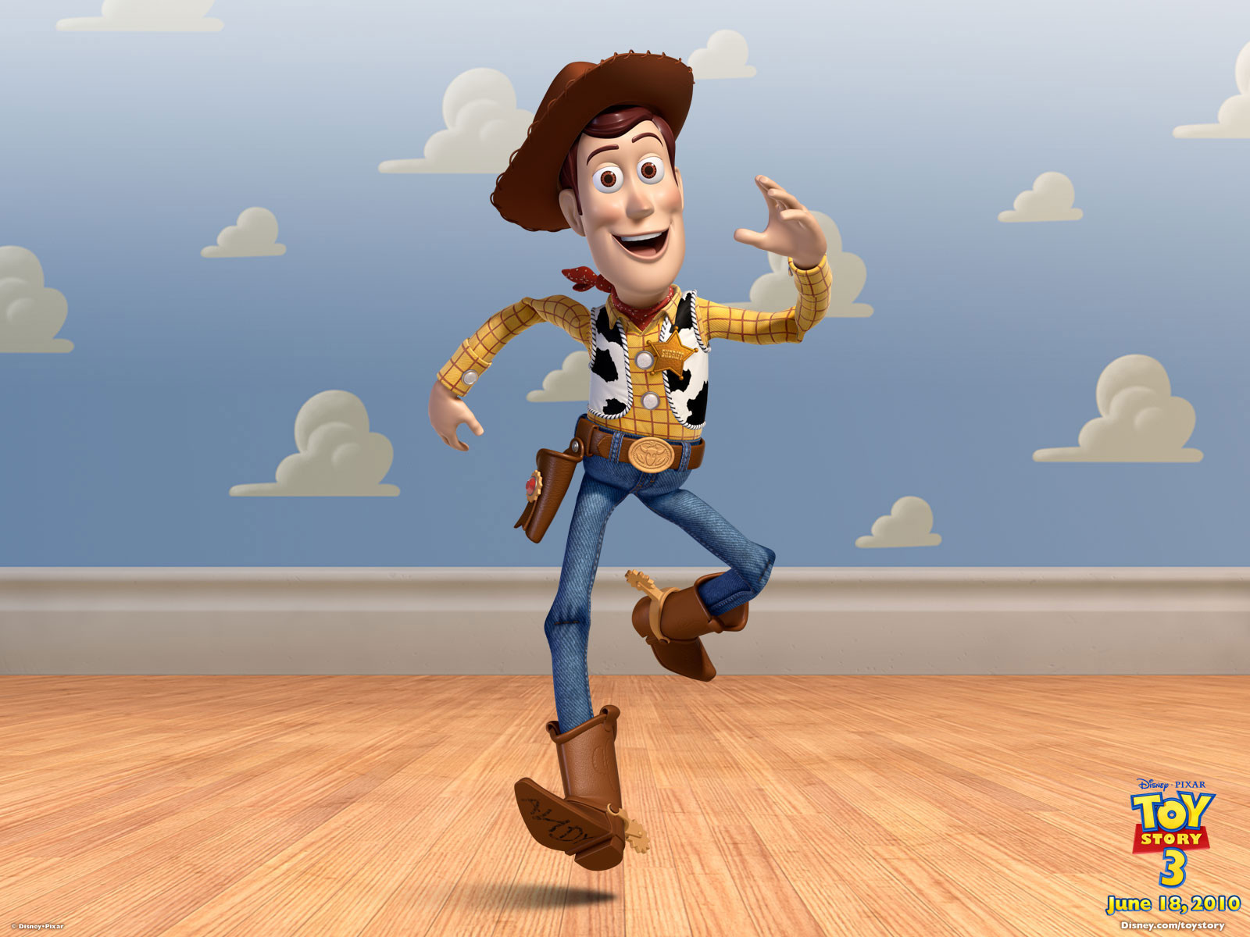 | 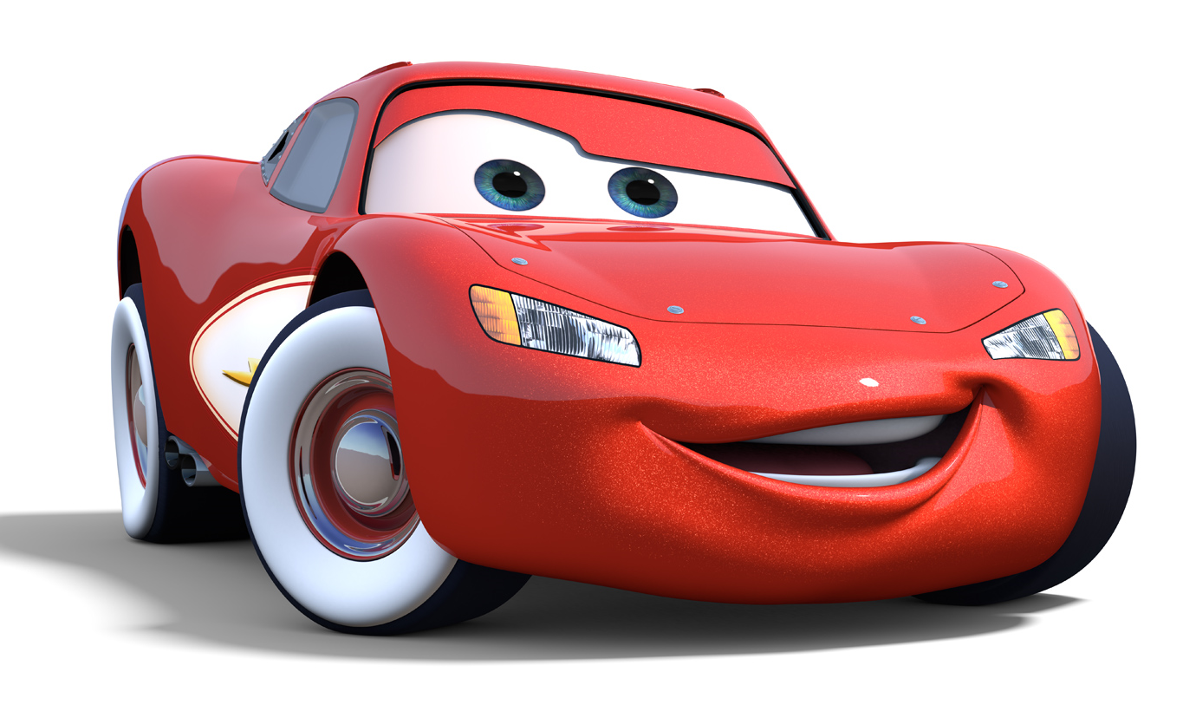 | 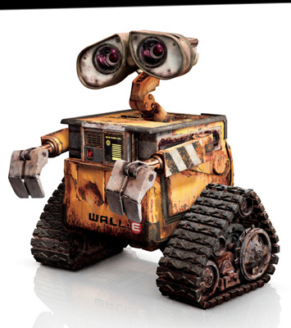
Special Skills:  Gadgets:  Comedy: | Special Skills:  Gadgets:  Comedy: | Special Skills:  Gadgets:  Comedy:
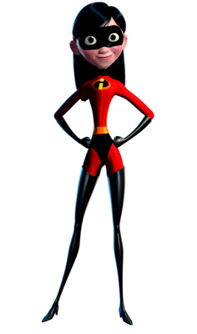 | 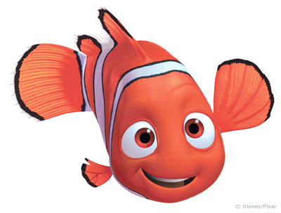 | 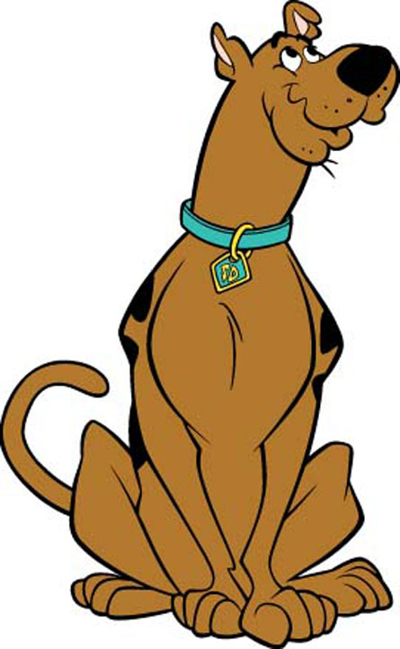
Special Skills:  Gadgets:  Comedy: | Special Skills:  Gadgets:  Comedy: | Special Skills:  Gadgets:  Comedy:

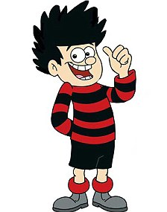 | 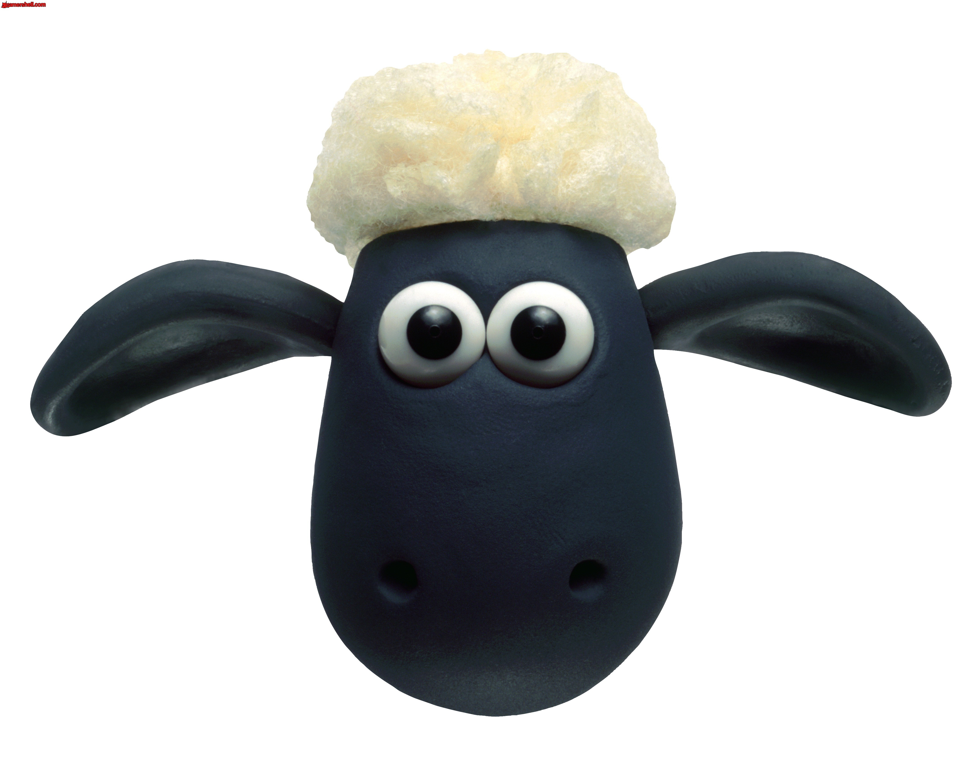 | 
Special Skills:  Gadgets:  Comedy: | Special Skills:  Gadgets:  Comedy: | Special Skills:  Gadgets:  Comedy:
 | 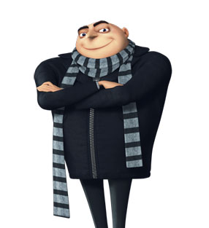 | 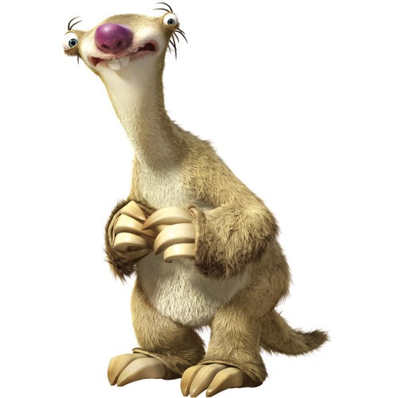
Special Skills:  Gadgets:  Comedy: | Special Skills:  Gadgets:  Comedy: | Special Skills:  Gadgets:  Comedy:
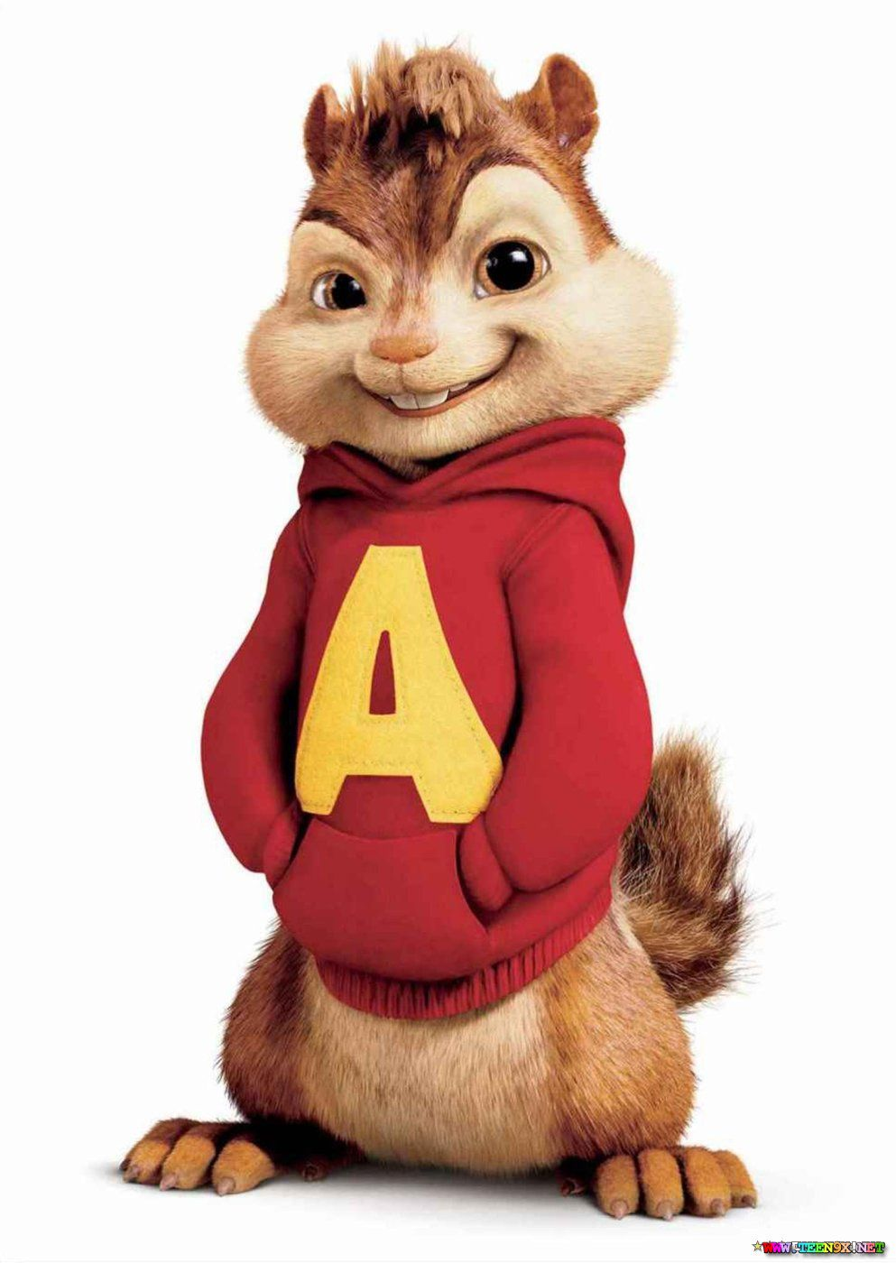 | 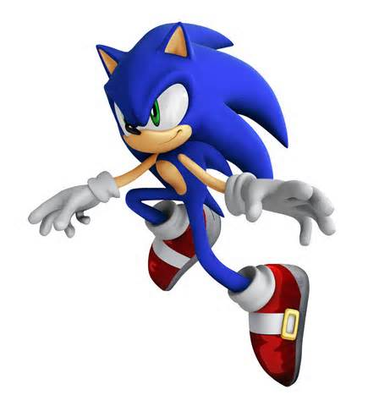 | 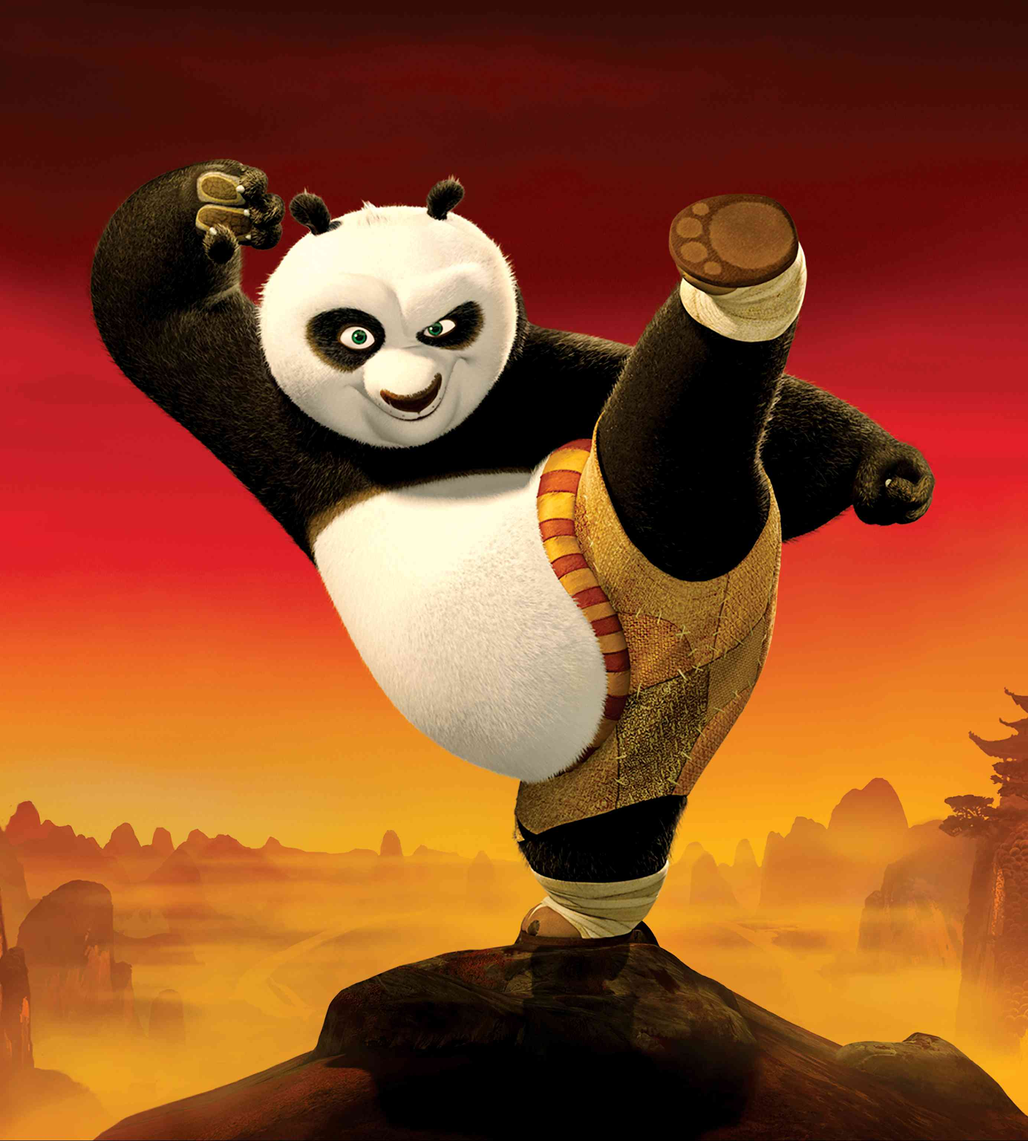
Special Skills:  Gadgets:  Comedy: | Special Skills:  Gadgets:  Comedy: | Special Skills:  Gadgets:  Comedy:

