Name: Teacher: Class:
9.2 Visualising and constructing
You need to learn to: | Pre-learning assessment | Post-learning assessment
- Use ruler and compasses to construct the perpendicular bisector of a line segment | 1,2,3 | 1,2,3
- Use ruler and compasses to bisect an angle | 1,2,3 | 1,2,3
- Use a ruler and compasses to construct a perpendicular to a line from a point (at a point) | 1,2,3 | 1,2,3
- Understand the meaning of locus (loci) | 1,2,3 | 1,2,3
- Know how to construct the locus of points a fixed distance from a point (from a line) | 1,2,3 | 1,2,3
- Identify when to use the locus of points a fixed distance from a point (from a line) | 1,2,3 | 1,2,3
- Identify when a perpendicular bisector is needed to solve a loci problem | 1,2,3 | 1,2,3
- Identify when an angle bisector is needed to solve a loci problem | 1,2,3 | 1,2,3
- Choose techniques to construct 2D shapes; e.g. rhombus | 1,2,3 | 1,2,3
- Construct a shape from its plans and elevations
- Construct the plan and elevations of a given shape
Assessments
Assessment | What score I think I’ll get out of 40  (complete before assessment) | What score I did get out of 40  (complete after assessment)
Diagnosis assessment | /11 = % | /11 = %
Test assessment | /11 = % | /11 = %

Name: Teacher: Class:
9.2 Visualising and constructing

You need to learn to: | Pre-learning assessment | Post-learning assessment
- Use ruler and compasses to construct the perpendicular bisector of a line segment | 1,2,3 | 1,2,3
- Use ruler and compasses to bisect an angle | 1,2,3 | 1,2,3
- Use a ruler and compasses to construct a perpendicular to a line from a point (at a point) | 1,2,3 | 1,2,3
- Understand the meaning of locus (loci) | 1,2,3 | 1,2,3
- Know how to construct the locus of points a fixed distance from a point (from a line) | 1,2,3 | 1,2,3
- Identify when to use the locus of points a fixed distance from a point (from a line) | 1,2,3 | 1,2,3
- Identify when a perpendicular bisector is needed to solve a loci problem | 1,2,3 | 1,2,3
- Identify when an angle bisector is needed to solve a loci problem | 1,2,3 | 1,2,3
- Choose techniques to construct 2D shapes; e.g. rhombus | 1,2,3 | 1,2,3
- Construct a shape from its plans and elevations
- Construct the plan and elevations of a given shape
Assessments
Assessment | What score I think I’ll get out of 40  (complete before assessment) | What score I did get out of 40  (complete after assessment)
Diagnosis assessment | /11 = % | /11 = %
Test assessment | /11 = % | /11 = %

9.2 Visualising and constructing Date:
Diagnosis (to be taken before the topic is taught)

Q) | Question | Workings and answer
1) | Use a ruler and compass to construct the perpendicular bisector of the line. |  | (1)
2) | Use a ruler and compass to bisect the angle. |  | (1)
3) | Use a ruler and compasses to construct a perpendicular to the line AB from C | B  A  C | (1)
4) | Describe what ‘locus’ means. |  | (1)
5) | Construct the locus of points that are 1cm from the line DE | E  D | (1)
6) | In which of these situations would constructing the locus of points a fixed distance from a point be useful? | - Finding the exact centrepoint between two towns on a map.  - Show on a diagram where a farmer needs to dig a straight trench that is equidistant from two adjacent hedges.  - Showing the area on a map covered by a radio transmitter. | (1)
7) | In which of these situations would constructing a perpendicular bisector be useful? | - Finding the exact centrepoint between two towns on a map.  - Show on a diagram where a farmer needs to dig a straight trench that is equidistant from two adjacent hedges.  - Showing the area on a map covered by a radio transmitter. | (1)
8) | In which of these situations would constructing an angle bisector be useful? | - Finding the exact centrepoint between two towns on a map.  - Show on a diagram where a farmer needs to dig a straight trench that is equidistant from two adjacent hedges.  - Showing the area on a map covered by a radio transmitter. | (1)
9) | Use a ruler, compass and pencil to construct a Rhombus |  | (1)
10) | P S F Front  Side Plan |  | (1)
11) | Front  Side Plan |  | (1)

9.2 Visualising and constructing Date:
Test (to be taken after the topic is taught)

Q) | Question | Workings and answer
1) | Use a ruler and compass to construct the perpendicular bisector of the line. |  | (1)
2) | Use a ruler and compass to bisect the angle. |  | (1)
3) | Use a ruler and compasses to construct a perpendicular to the line AB from C | C  B  A | (1)
4) | Describe what ‘locus’ means. |  | (1)
5) | Construct the locus of points that are 1cm from the line DE | E  D | (1)
6) | In which of these situations would constructing the locus of points a fixed distance from a point be useful? | - Finding the exact centrepoint between two towns on a map.  - Show on a diagram where a farmer needs to dig a straight trench that is equidistant from two adjacent hedges.  - Showing the area on a map covered by a radio transmitter. | (1)
7) | In which of these situations would constructing a perpendicular bisector be useful? | - Finding the exact centrepoint between two towns on a map.  - Show on a diagram where a farmer needs to dig a straight trench that is equidistant from two adjacent hedges.  - Showing the area on a map covered by a radio transmitter. | (1)
8) | In which of these situations would constructing an angle bisector be useful? | - Finding the exact centrepoint between two towns on a map.  - Show on a diagram where a farmer needs to dig a straight trench that is equidistant from two adjacent hedges.  - Showing the area on a map covered by a radio transmitter. | (1)
9) | Use a ruler, compass and pencil to construct a Hexagon |  | (1)
10) | P F S Front  Side Plan |  | (1)
11) | 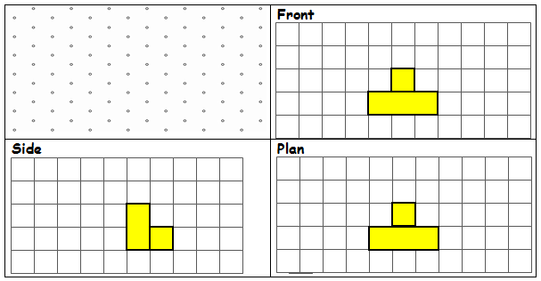 |  | (1)

