10 a  n^{th} term | Write down the next three terms in the sequence  11, 15, 19, 23, ……, ……, …… (1)  Write down the rule for the sequence  ………………………………………….  (2)
9 a  Substitution | V = 3b + 2b²  - Find V when b = 3 ……………………………  (1)  - Find V when b = - 4 …………………………….  (2)
8 a  Expanding and factorising expressions | Expand 4( x + 2 ) ………………………………..  (1)  Simplify 3x ² + 12x  ………………………………..  (2)  Expand ( x + 3 )( x + 4 )  …………………………………  (2)
7 a  Simplifying and collecting terms | - Simplify d + d + d + d + d …………………………  (1)  - Simplify 3 x m x 2 …………………………  (1)  - Simplify 6k + 3j – 2k + 5j …………………………  (2)
6 a  Solving equations | - Solve 4x = 20 x = …………………………..  (1)  - Solve y – 8 = 13 y = ……………………………  (1)  - Solve 3m + 7 = 34 m = ………………………….  (2)
5 a  Interior/ Exterior angles | 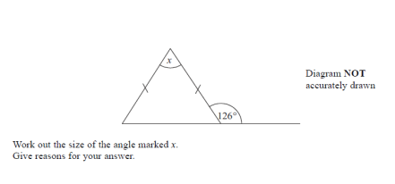  (4)
4 a  Angles in parallel lines | 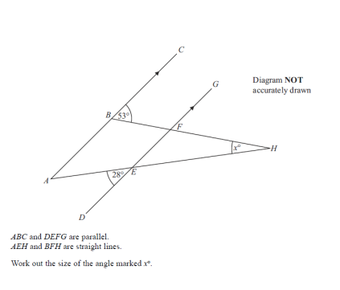  (3)
3 a  Stem and Leaf | 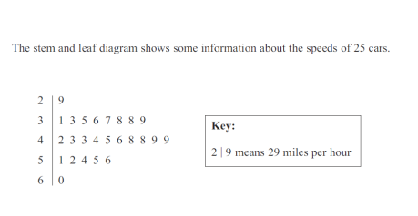  How many cars had a speed of more than 50 miles per hour?  ……………………………  (1)  Find the median speed …………………………….mph  (1)  Work out the range of speeds …………………………….mph  (1)
2 a  Multiply numbers  (non calc) | Multiply 36 x 42  …………………………………….  (2)
1 a  Tessellation | 